

# Can you help them

h a e g i d n o p o o g o l f d l u l c l u b c v g t e k b e j h o a t b i r d i e r l e a f p r n n q f r l t w y h p o r t l x z s t i w n e u m e a g l e n e

**How many word can you find?**

club ball tee hole pond golf

birdie

hole in one flag

eagle putter trophy



**menu**

2 CO U R S E S £ 1 4 . 9 5 | ADD A THIRD COURSE £4.00

**STARTERS**

Garlic Bread

Soup of the Day

Crudites with Hummus

**MAINS**

Sausage & Mashed Potatoes

Fish Goujons & Fries,

Chicken Breast, Mashed Potatoes, Gravy

All served with Peas & Carrots

Macaroni Cheese

Cheeseburger & Fries, Beans

**DESSERTS**

Ice Cream

Fruit Salad

Chocolate Brownie

(V) Vegetarian (VE) Vegan. A number of our dishes can be adapted to cater for your food allergies and dietary requirements. Please speak to your server who will be able to advise.

Full allergy information for each dish is available upon request.

**find their golf balls?**



**Colour by numbers**

2

4

4

4

2

2

2

2

2

1

2

2

1

2

2

1

2

2

1

2

1

2

1

2

1

2

1

2

4

2

3

2

1

4

1

2

2

1

1

3

2

2

1

1

2 1 2

1

2

2

2

2

2

1

2 1

2

1

2

1

4

2

5

5

**1** BLUE

**2** RED

**3** YELLOW

**4** BLACK

**5** GREEN

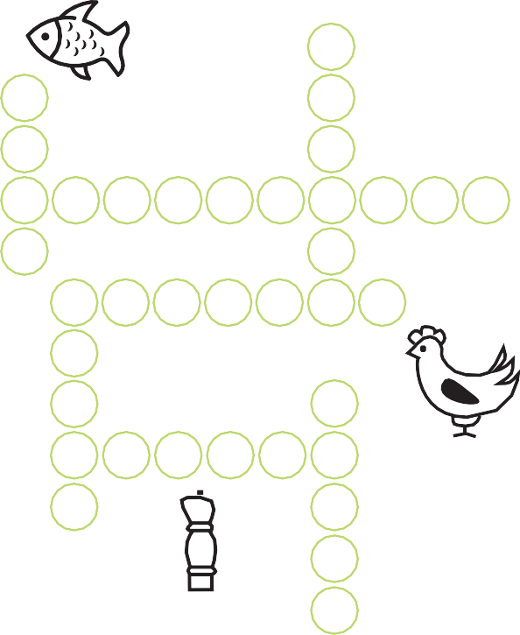

**Can you solve the menu puzzle?**

s

c

e

e

p

r



Answers: Missing objects 1) A golf flag 2) Dad’s pocket 3) A cloud 4) The small pond 5) The boy’s club 6) Car bumper 7) The flash on the car 8) Trees on the hill

**Can you unscramble these words?**

renge rocseu

ktoser uchlseuob ukebrn deadci hdcegdlo

shhhhh... some clues:

clubhouse caddie course

bunker stroke gleddoch green

**Look at the picture...**

**can you spot 8 differences?**

